**1.Console and Cloud Shell**

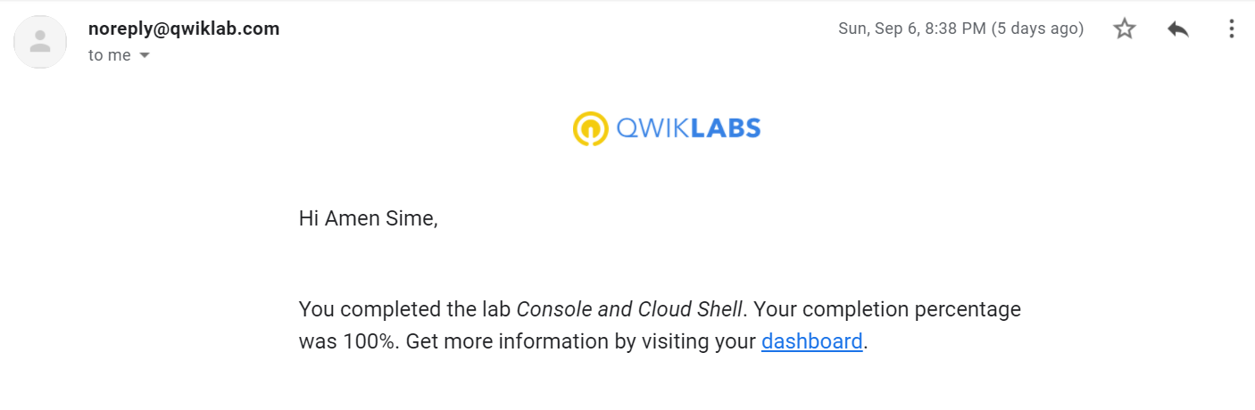

**2. Infrastructure Preview**

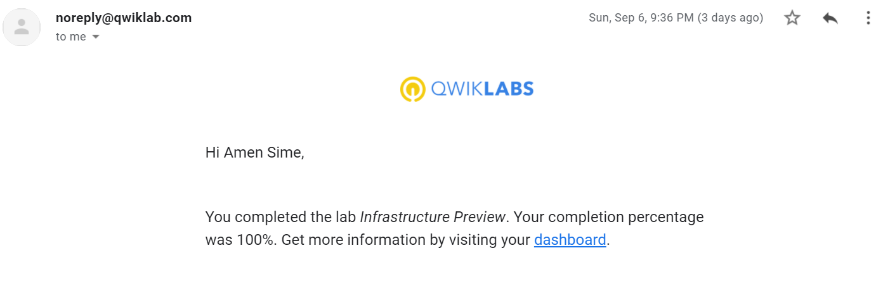

**3. VPC Networking**

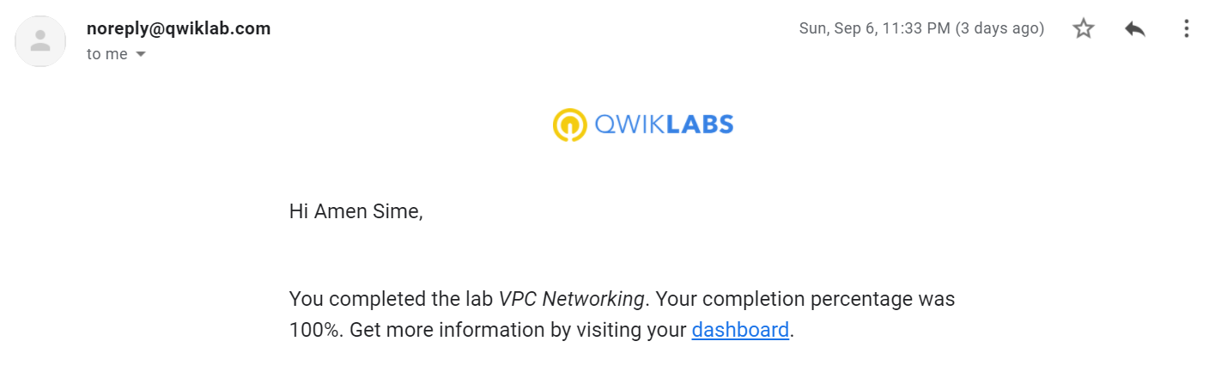

**4. Implement Private Google Access and Cloud NAT**

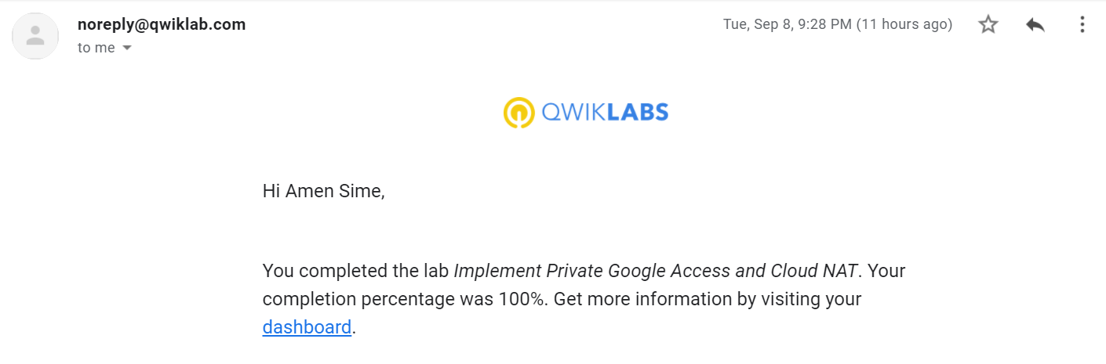

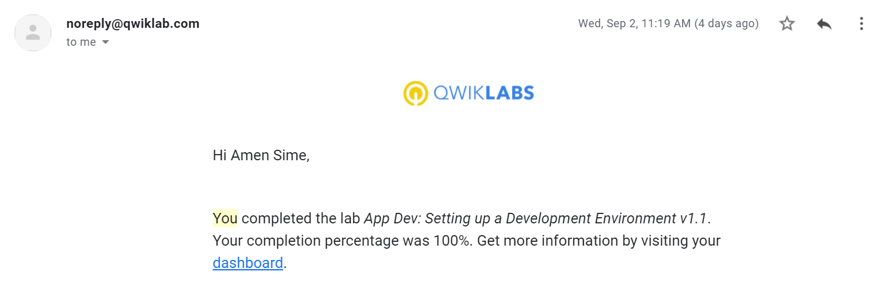**5. App Dev: Setting up a Development Environment v1.1**

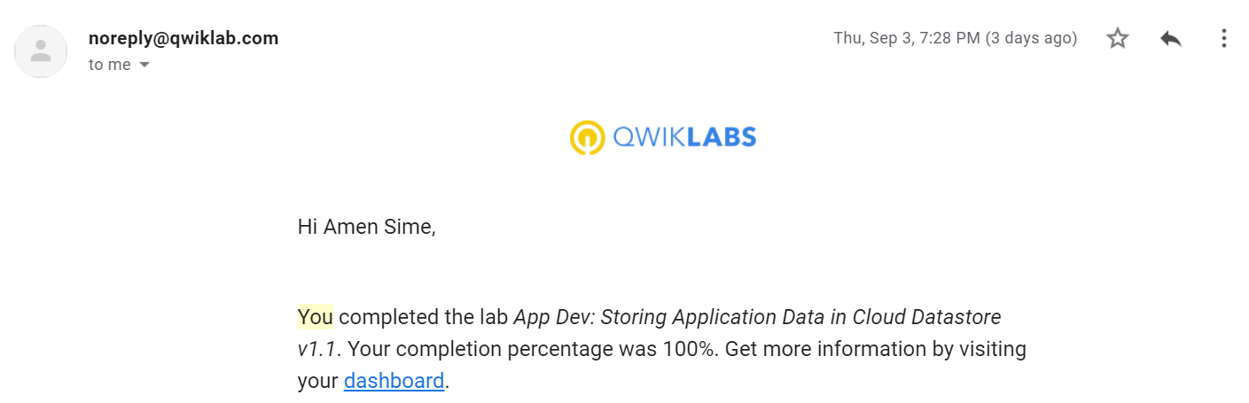**6. Storing Application Data in Cloud Store**

**7. Storing Image and Video Files in Cloud**

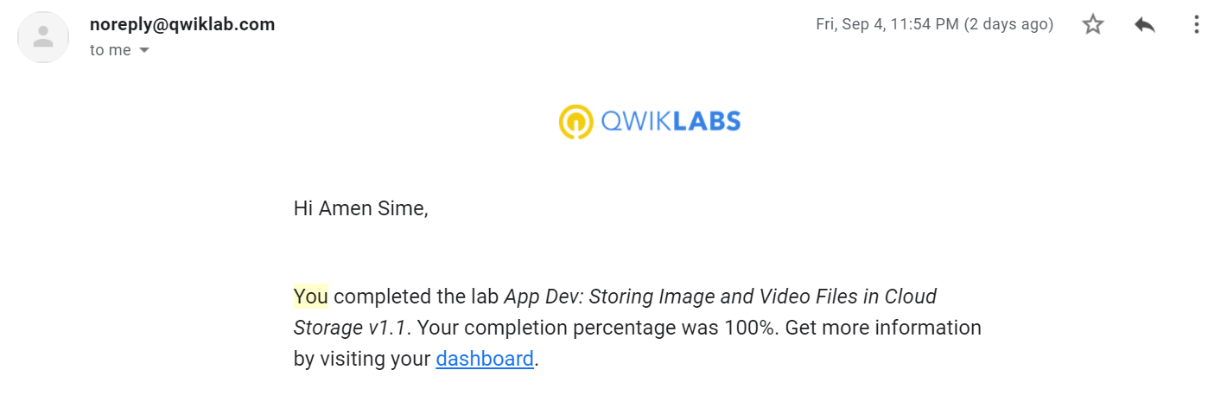

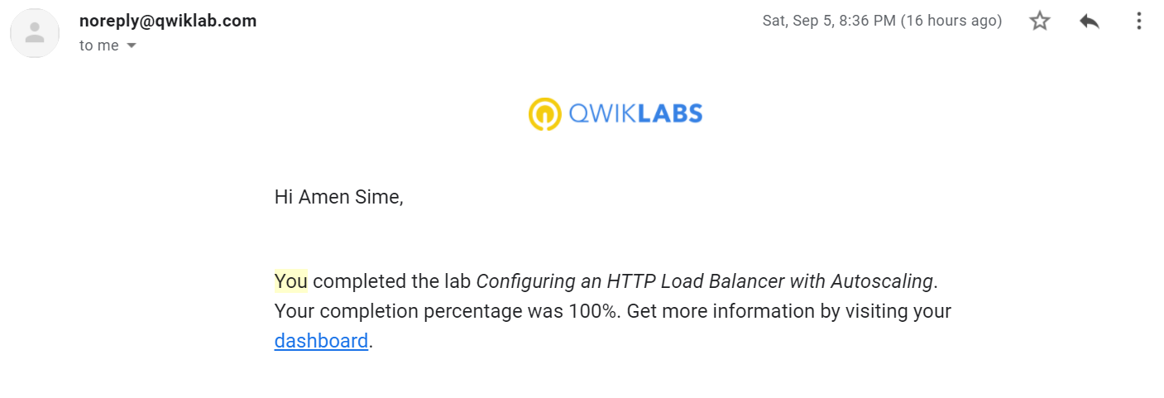**8. Configuring an HTTP Load Balancer with Auto-scaling**

**9. Getting Started with Big Query**

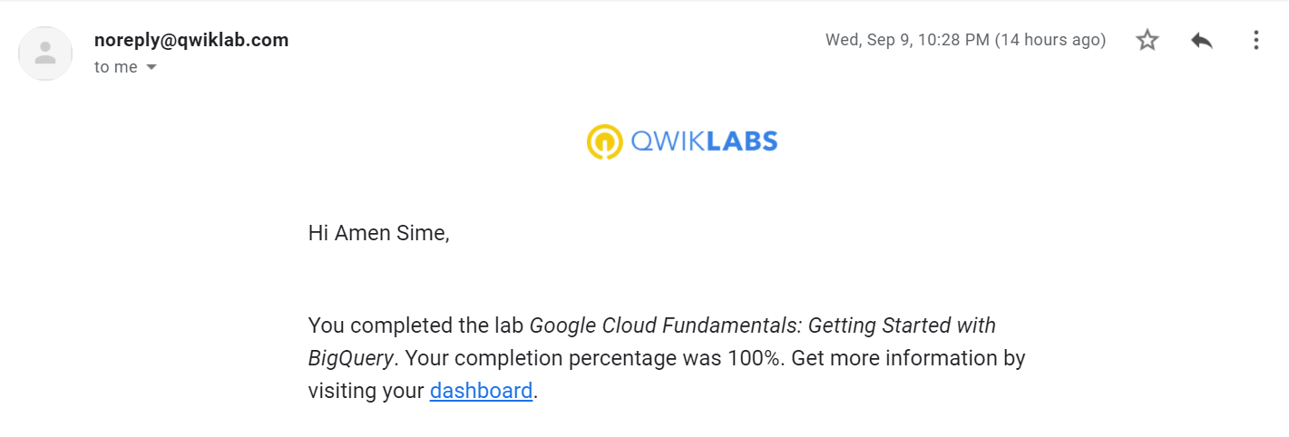

**10. Working with Virtual Machines**

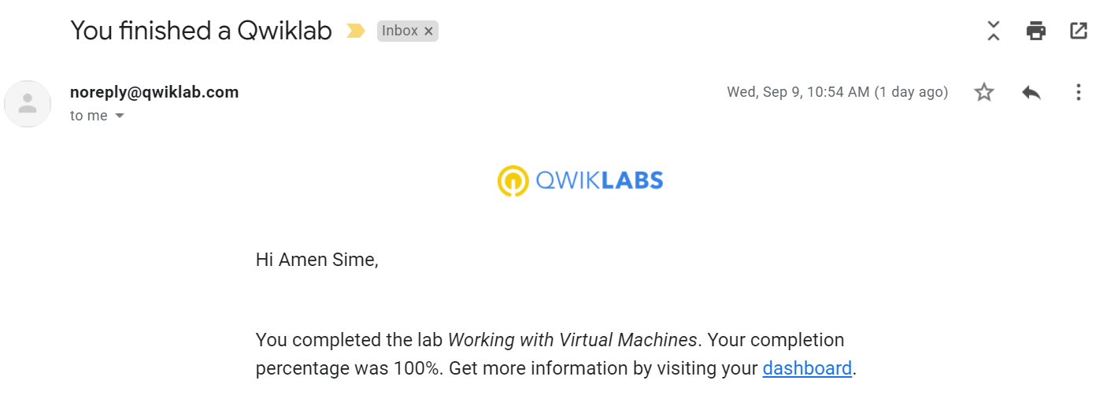

**11. Getting Started with Deployment Manager and Cloud Monitoring**

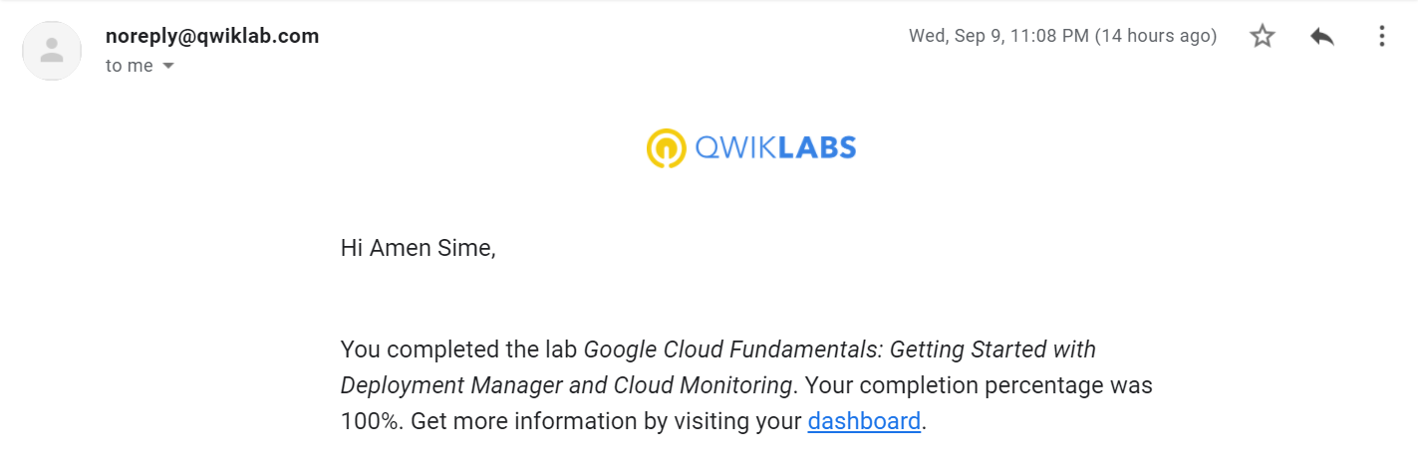

**12. Virtual Private Networks (VPN)**

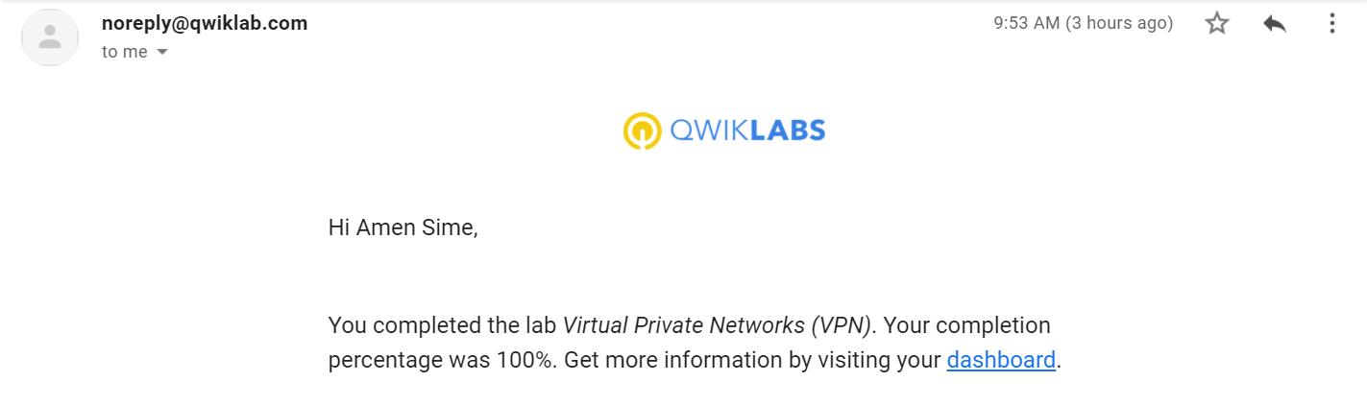

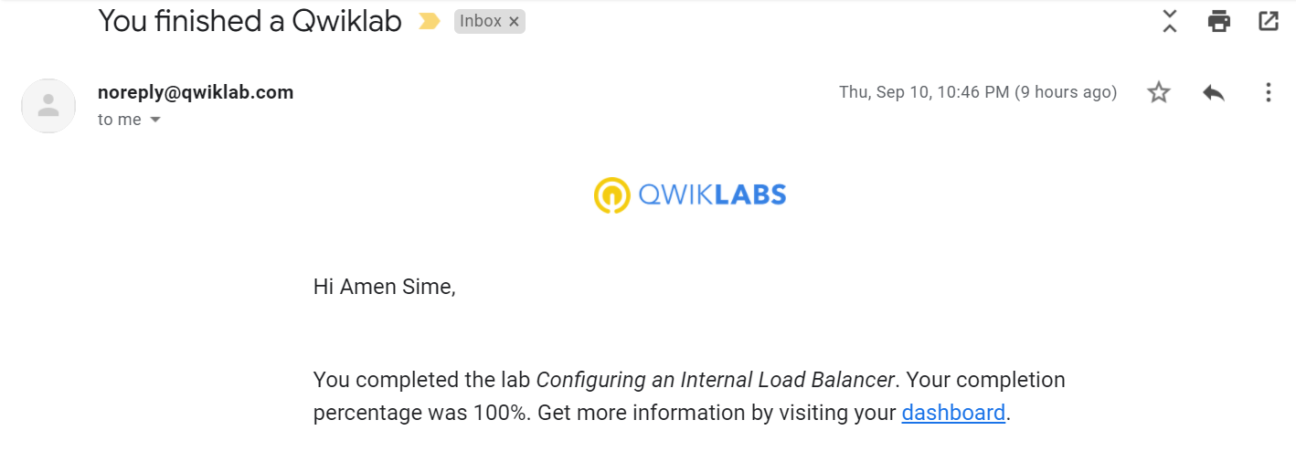**13. Configuring an Internal Load Balancer**

**14. Automating the Deployment of Infrastructure using Deployment Manger**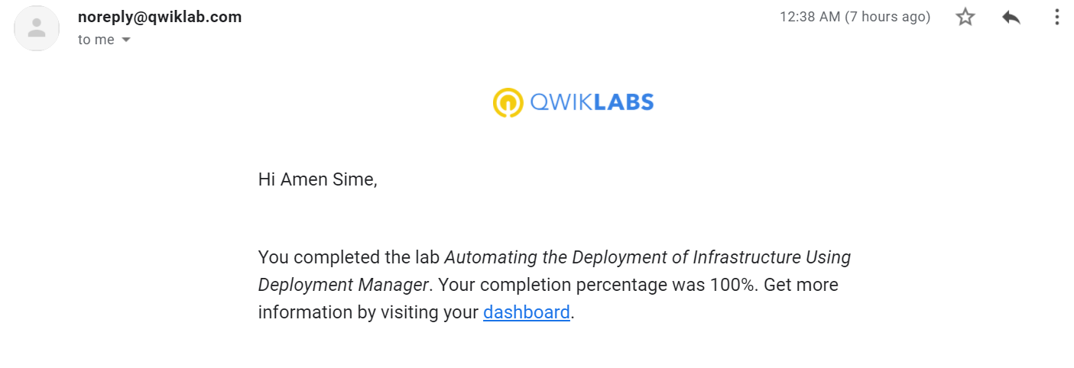

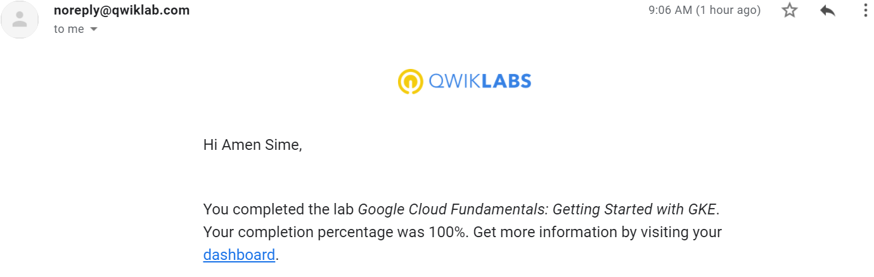**15. Google Cloud Fundamentals: Getting Started with GKE**